**Curriculum Vitae**

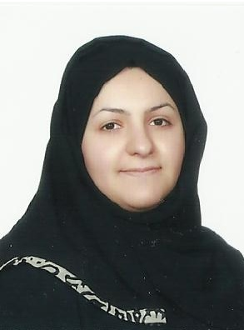

**Personal Information:**

#### Name : Fatima Jaffar Shaikh Ahmed Al.Asfoor

CPR No : 880904054

Nationality : Bahraini

Date of Birth : 29th September, 1988

Marital Status : Married

Languages : Arabic, English

Address : House: 170 - Road: 2607 - Block: 1026- Karzakkan.

Contact : +97333005687, +97333334882

E-Mail : umsarah_88@live.com

**Objective:**

Develop and advance in my career within a challenging and diverse environment, where I can refine my competences and acquire new ones all while striving to excel in the dedicated performance of my duties.

**Qualifications and Trainings:**

**2015 :** Attended the **Career** **Hunter Workshops at University of Bahrain**.

**2014** **:** Holder of **BSC degree** **in Accounting** from University of Bahrain.

**2009** **:** Training program in **Ministry of Social Development.**

**2009** **:** Holder of **Diploma in Commercial Studies** from University of Bahrain.

**2006** **:** Secondary school certificate from Jidhafs secondary school, Scientific Stream

with GPA 88%.

**Personal Skills:**

* Fast learner, always seek to expand my knowledge and acquire new professional skills
* Creative thinker and efficient problems solver.
* Good performance under pressure and various challenges.
* Effective member in team working environment.
* Have enough knowledge for efficient planning and analyzing tasks.
* Acquire excellent communication, presentation, problem solving, and creative thinking in addition to leadership skills.
* Computer and technological skills.